TRACE THE DOTTED SHAPES AND NAME THE SHAPES.
COLOUR THE SHAPES ACCORDING TO THE COLOUR CODE:
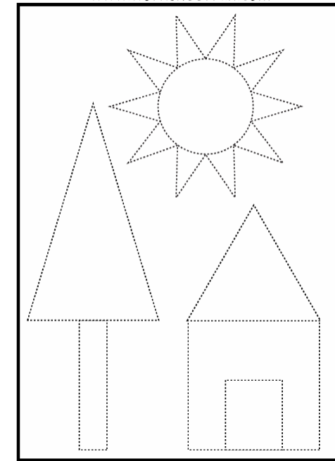
TRIANGLE: BLUE; CIRCLE: ORANGE; SQUARE:RED; RECTANGLE:GREEN

